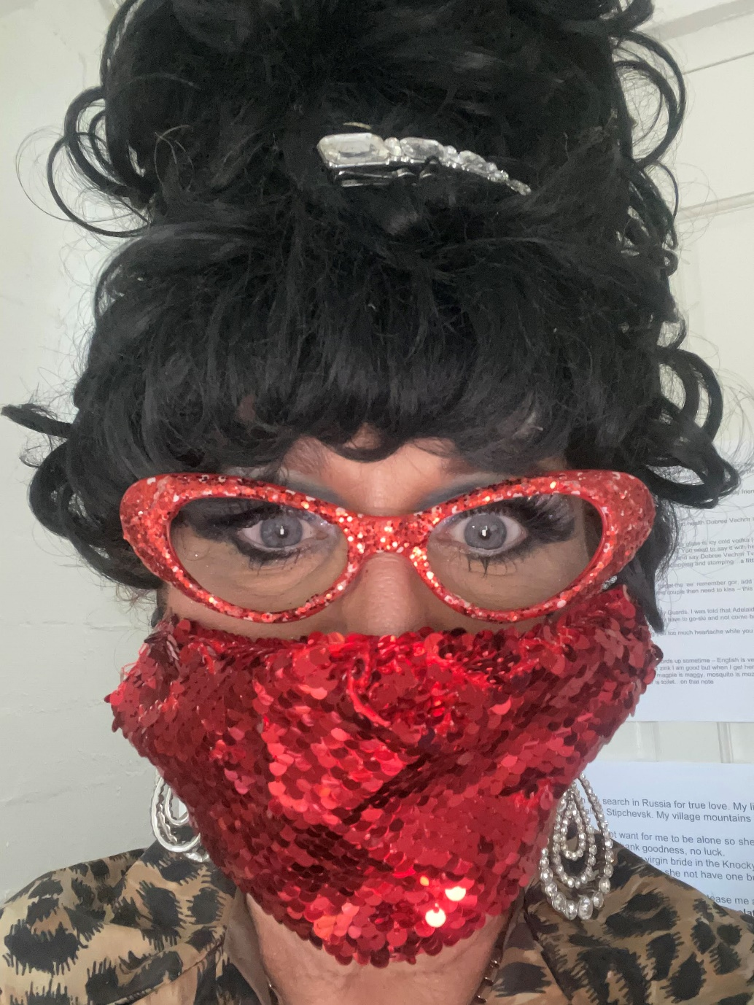

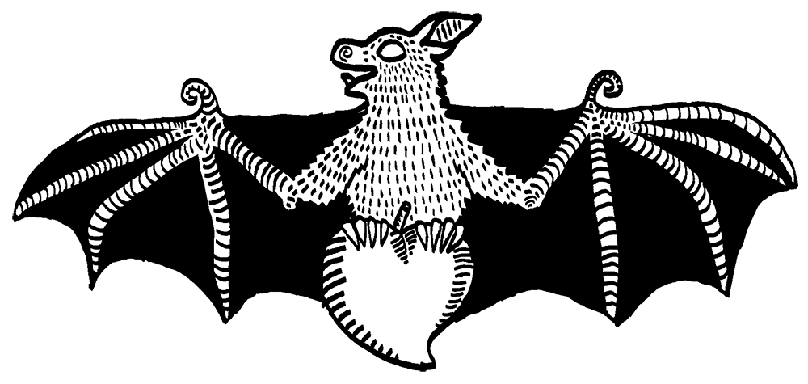

**LUCKY BAT**

A Zukooska of the Sickle of Love

**Big Love! Big Dreams! Big Laughs! Big Hair!**

Come on a musical adventure. It’s like Russia with a 60’s twist, where you can laugh, tap your feet and sing out loud!

A ‘snack’ of Sveta’s adventures looking for love in Australia. She disappeared for a while. Rumours are that she came to Darwin before COVID hit.

Where has she been? Did she meet an old croc? What happened on her date with Barry? How many dates has she had? Has she finally stopped searching?

Sveta will take you on a little adventure, challenge you to learn a few Russian words and make sure you take a little of the Russian spirit home with you.

**Lucky Bat Café Pizzeria**

8 Pavonia Place, Nightcliff

Thursday 15th July 9pm

Tickets $15

<https://luckybat.space/event/fringe-of-the-fringe-presents-a-zukooska-of-the-sickle-of-love/>



[**www.sveta.com.au**](http://www.sveta.com.au)

