Buy, Sell, Swap, Donate, Pay it Forward
Clothes, Shoes, Jewellery & Accessories, Plants, Household Items, Books, Games and Bric-a-brac.
(Sellers set up from 8am – it’s FREE to have a stall)
Sunday, 5 December 2021* 9am-12pm
ALAWA HALL Lakeside Drive Alawa.
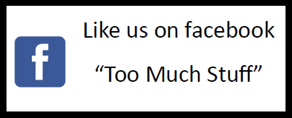
Email esther@uselessplastic.org to register your interest.
Too Much Stuff – Darwin’s only recycling, upcycling flea market.
Proudly supported by Charles Darwin University www.cdu.edu.au/sustainability**

*The last Sunday of every month from May – October 2021 and the first Sunday in December 2021
**Finalist in the Sustainable Enterprise Award category of the 2019 NT Natural Resource Management (NRM) Awards.

